What Our Project Accomplished:
This fantasy football application allows users to create teams, and compete with one another based on real world NFL data. The application implements a full-featured login system, and supports individual teams and trading. Scoring data comes from NFL.com, and is based on real NFL data.

Our Project’s Usefulness
The fantasy sports market, which is dominated by fantasy football, is widely considered to be a multi-million dollar market in terms of advertising and being a gateway to additional television and related sports revenue.
Designing a fantasy football website with analytical tools is a real work problem whose solutions continues to evolve with each new iteration of fantasy football league design. Our site is based on real world data, and implements the basic functionality of a fantasy football site.

Data in Our Database
User and teams data are created as the application runs, by logged in users via the web interface. Real world data, including positions, names, real team names, and statistics / performance are pulled from NFL.com via a PHP script that scrapes the player data. This script is run on a weekly basis as a cron job and likewise updates matchups and scoring in the fantasy games based on that weeks real data.

ER Diagram
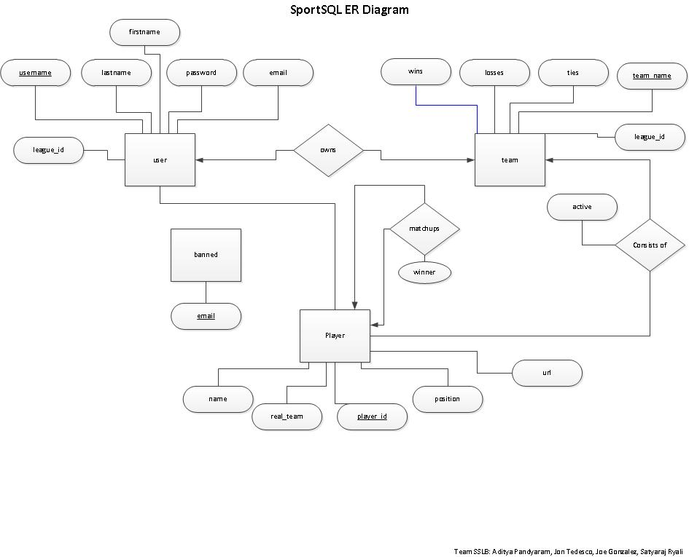

Schema:
user(username, password. email, firstname, lastname, league_id)
team(team_name, wins, losses, ties, user_name, league_id)
player(player_id, position, real_team, name, url)
consists_of(player_id, team_name, active)
banned(email)
matchups( player1, player2, winner)

Functional Dependencies:
Username-> Password, E-mail, Name, League ID
Team Name -> Record, Usename, League Id
Player Id -> Stats, Position, Real Team, Name

Constraints:

Functionalities of Our Project
  - Create, delete, modify accounts, remove (checks for duplicate accounts, etc)
  - Dynamically display page components based on logged in user
  - Performing administrative tasks such as deleting and banning a player
  - Show real -world players available for fantasy teams and their real teams (sortable)
  - Show sortable rankings of current fantasy teams
  - Show and rank fantasy teams and highlight logged in user’s team
  - Contact us tab with contact info and email script, with other PHP widgets

Example Basic Function
One basic function we implemented was adding players to a user’s fantasy team, by selecting players from a pool of players that have not yet been added to fantasy teams. An example query, using PHP variables, is shown below:

"SELECT * FROM player WHERE position='$position' AND player_id NOT IN(SELECT player_id FROM consists_of)"

This simple query will select a list of players from the list of ‘real world’ football players, specifically ones that have not yet been added to any user’s fantasy team. Using this list of players returned, users can add players to their fantasy team.

Advanced Functions
- Security checks for input forms
This feature will strip all escape characters from input forms whose values may be used in database queries. (e.g. malicious users could hack the input fields using escape characters and partial SQL queries). This is an advanced feature because it is not absolutely necessary for the application, but is good practice for any interactive web application.

- A full-featured login system
A role-based login system, which allows users to create accounts, delete accounts, and modify accounts. Users each have their own fantasy team and can trade players with other users. Likewise, the login system features an administrative account which deletes accounts and bans users. Likewise, pages are rendered dynamically based on the current logged in user. This is an advanced feature because we implemented the system ourselves, using session variables to dynamically render pages based on user data. We also created an admin account for administrative functions, which is above and beyond the fundamental requirements for a login system.

- Weekly updates to standings using real data
A cron job runs weekly on the server that grabs player statistics from NFL.com for the previous weeks. Using this data, the script scores fantasy teams and updates standings of the fantasy teams in the league. This is an advanced function because it is beyond the scope of a normal web-based application, but would be nice for this application.

Technical Challenges
One technical challenge we faced was using cPanel specifically. We originally planned to use views for the trading system, but found that cPanel does not support views, and also does not support triggers. We worked around these constraints, and managed to use cPanel’s cron job functionality to automatically run a script on a weekly basis to add a realistic aspect to our application.

Likewise, we faced techincal challenges in writing clean code for our web application. We strove to modularize our PHP code, and did so by abstracting many of the common database interactions, and automate the basic connections to MySQL. Likewise, we used PHP sessions frequently to pass data between pages, display error messages, implement the login system, and PHP includes frequently to improve readability of our code.

Finally, we were unable to use YQL as we expected to automatically gather real-world data, but managed to overcome this obstacle using a PHP script to scrape NFL.com.

Sticking to Plan
We changed our advanced features several times, abandoning the “stretch” goal of using prediction algorithms using history of games. However, we implemented all other features that we set out to do, implementing three advanced features instead of two.

Division of Labor
- Jon
  - final report
  - administrative tasks (timelines, setting up meetings, ide, version control, etc.)
  - all gui work (CSS template, skeleton site, messages, banners)
  - “Contact Us” tab
  - Sessions
  - PHP widgets
  - “Players” and “Standings” tab
  - PHP database abstraction, rendering, general database tools library
  - Modularization of code
  - Implemented skeleton of login system
  - “My Account” tab
  - Built frontend of “My Team” tab
- Joe
  - implemented “Manage team” component of “My Team” tab
  - added constraints to DB
  - implemented PHP scraping script for NFL.com
  - parsed and inserted real data into database
  - implemented teams scoring
  - implemented team setup & modification
- Aditya
  - Wrote skeleton login system
  - implemented player trading
  - implemented “Trade Players” component of “My Team” tab
  - implemented security features
  - implemented “admin” tab and added GUI hook
  - Drafted ER diagram
- Kiran
  - implement matchups (“matchups” tab)
  - implmeneted GUI for matchups
  - implement scheduling
  - update winners and losers based on point totals
  - scheduling weekly run scripts

